Suggestions for using the Kit Resources

1. Adaptations to the Environment Photographs
These can be used to stimulate discussion about the special features that help living organisms to survive in their environments. The information and tables in appendices 1 and 2 give some general adaptations and examples for the organisms in the photographs.
When discussing adaptations, try to encourage pupils to describe the adaptation and explain how it helps the organism to survive.

2. ‘Sorting and Classification’ Pictures
These can be used to observe and describe simple characteristics of the organisms and to sort them into groups based on similarities and differences between them. Encourage sorting based on physical characteristics rather than habitat or behaviour (eg, animals with scales and fins, rather than animals that live in water).
The plastic sorting circles can be used to investigate interconnections between groups.
The pictures can also be used to classify organisms into the main taxonomic groups. Some information to help with this activity is given in appendices 3, 4 and 5. Remember that all classification systems are ‘man-made’ and consequently some organisms are difficult to ‘fit in’.
Each set of 17 pictures contains
- 2 fungi
- 4 plants
- 3 invertebrates
- 2 fish
- 1 amphibian
- 1 reptile
- 2 birds
- 2 mammals

The pictures in each set are different so sets can be combined to provide more examples. Each set is coded with a coloured spot, so please return the correct pictures to each envelope.

3. Key Cards and Pictures
There are two different types of key provided to identify the birds in the pictures, a ‘branched’ key and a ‘question’ key. The answers are:

1 = Goldeneye
2 = Hen Harrier
3 = Little Owl
4 = Tree Sparrow
5 = Mistle Thrush
6 = Herring Gull

Pupils can then use the picture sets of pigs and sheep to practise making their own branched or question keys. Encourage them to begin by separating the pictures into two groups and then sub-dividing each group. Try to avoid vague descriptions such as ‘big’ and ‘small’ and only use visible features. Note that the names of the animals are on the back of each picture. Pupils can try their keys out on each other to see how successful they are.

Suggestions for Pigs
Curly tail/straight tail
Black spots/no black spots
Pointed snout/squashed snout

Suggestions for Sheep
Black face/white face
Long hair/short hair
Horns/no horns

4. Food Chain Activities
- The large photographs of the rabbit and peregrine falcon can be used to stimulate discussion about the features that help animals to be successful as predators or prey. Some suggestions are given in appendix 6. The posters show the fields of vision of a rabbit and a cat.

- The four large pictures of the dead leaves, worm, mole and owl can be used to build up a simple food chain and introduce key terms. The adaptations of the animals can also be discussed.

Leaves Worm Mole Owl
Producer Consumer Consumer Consumer
Herbivore Carnivore Top Carnivore
Prey Predator

- The food chain mobiles can be cut out, coloured and constructed. Note that the kestrel/mouse mobile needs a plant food source for the mouse.

- The wall hanging, pictures, arrows and key words can be used to build up and label a number of different food chains. It should also be possible to link together different food chains to produce a food web. Some information to help with this activity is provided in the accompanying table.

- The CD ‘Discover Antarctica’ could be used to investigate food chains in a different habitat.

- Local habitats could be studied to investigate the feeding relationships that exist in them. The TSN ‘Habitats’ Kit contains equipment for sampling a variety of habitats.

Appendix 1 Adaptations to the Environment

An adaptation is a special feature that helps a living organism to survive in its environment.

Some examples are:

- Adaptations to a particular food source, eg beak shape in birds and tooth shape in mammals.

- Camouflage to enable predators to approach prey undetected or prey to hide from predators.

- Thick fur to insulate against heat loss in cold conditions.

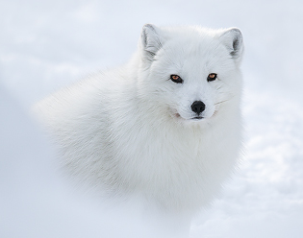
- Small ears to reduce heat loss by radiation in cold climates (eg Arctic fox) or large ‘radiator’ ears to increase heat loss by radiation in hot climates (eg Desert fox).
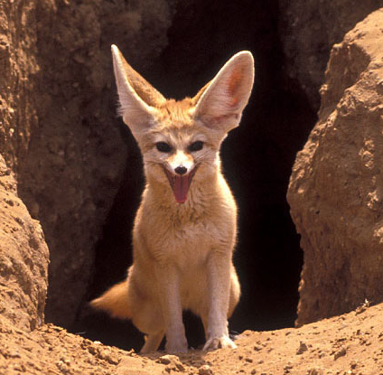

- Streamlined shape and webbed feet for efficient swimming.

- Features to reduce water loss by evaporation in desert plants eg leaves with a reduced surface area, hairy leaves to trap water vapour, thick, waxy cuticles (outer layer), reduced number of sunken stomata (pores in leaves for gas exchange).

The tables in appendix 2 give more examples for the organisms in the photograph sets.

Appendix 2 Some information to help with discussions about adaptations.
1. Plants
All contain the green pigment chlorophyll enabling them to produce food by photosynthesis using energy from sunlight.
Organism | Habitat | Adaptations
Cactus | Deserts | Swollen stems store water and carry out photosynthesis; leaves reduced to spines as defence against herbivores and to reduce surface area for water loss by transpiration
Palm | Widespread in the tropics | Feathery leaves reduce damage from wind and sand; coconut fruits need a sandy soil to germinate and can tolerate salt, so can grow in conditions where there is little competition from other plants; shallow, spreading roots can absorb surface water produced by condensation at night
Pine | Widespread, can survive at low temperatures and in dry conditions | Evergreen, so needs to reduce water loss in winter when ground water may be frozen; needle-like leaves have reduced surface area, a thick waterproof cuticle and sunken stomata
Seaweed | Rocky shores | Tough, leathery fronds to withstand wave action; slimy mucilage prevents desiccation at low tide; holdfast to attach to rocks
Sundew | Acid, peaty soils low in nutrients | Insectivorous – traps insects in sticky secretions and digests them for nutrients eg nitrates

2. Birds
All have feathers for insulation against heat loss, wings for flying (except the penguin) and beaks for feeding. Beaks, legs and feet may show adaptations to a particular diet and habitat.
Organism | Adaptations
Bluetit | Thin, short, pointed beak to pick up insects and small seeds
Heron | Long, sharp, dagger-like beak to spear fish; long legs to wade in deep water
Owl | Hooked beak to tear at prey; hooked talons to catch prey; large eyes facing forwards to judge distance in dim light
Pigeon | Short, stubby beak to eat large seeds
Seagull | Large, strong beak to catch fish and marine invertebrates
Swan | Wide, flat beak to sieve food from water; webbed feet for swimming
Penguin | Streamlined shape and webbed feet for swimming; wings have become flippers for swimming instead of flying; thick, downy feathers for insulation in cold conditions; brood pouch to incubate egg and protect hatched chick

Fish and Reptiles
Organism | Habitat | Adaptations
Fish | Water | Streamlined shape and slippery surface to reduce water resistance; gills for gas exchange; scales for protection; dorsal/ventral fins for stability; paired pectoral and pelvic fins for steering and braking; spotted pattern for camouflage
Lizard | Hot and dry, eg deserts | Dry , scaly skin to reduce water loss by evaporation;long, forked tongue flicked out to catch prey; behavioural adaptations eg basking to warm up and keeping one foot off the ground to avoid overheating

Mammals
All have a body covered with hair or fur; females give birth to live young and have mammary glands to suckle their young.
Organism | Habitat | Adaptations
Camel | Desert | All fat stored in hump, helping it to lose body heat by radiation; large feet to spread weight on sand; can tolerate large changes in body temperature without sweating; long eyelashes act as sunshades; nostrils can be closed off to prevent intake of sand
Mouse | Widespread | Typical prey organism : large eyes on side of head for good all round vision in dim light; large ears to sense direction of sound; whiskers sensitive to touch; teeth for gnawing seeds; coloured fur for camouflage
Polar bear | Arctic | Thick, white fur for insulation and camouflage; small ears to reduce heat loss; sharp teeth and claws to catch and eat prey; eyes facing forward to judge distance; big feet to spread weight on snow
Reindeer | Arctic | Thick fur for insulation; large feet to spread weight on snow; large, sensitive nose to sniff out food (lichen) under snow
Seal | Water | Streamlined shape to reduce water resistance when swimming; flippers for movement in water; thick layer of blubber for insulation in water
Whale | Water | Streamlined shape, flippers and blubber as for seal; baleen mouthparts adapted to sieve food (plankton) from water

Appendix 3 Variation and Classification

Classification
The pictures in each set can be sorted into 3 major groups or Kingdoms
- The 3 major groups (Kingdoms) are
Fungi – lack chlorophyll, so cannot make their own food by photosynthesis; grow on dead organic matter or other living organisms; includes mushrooms, toadstools, moulds and yeasts.
Plants – contain the green pigment chlorophyll enabling them to produce food by photosynthesis, using energy from sunlight.

Animals – obtain their food by eating plants or other animals.

NB: Two other kingdoms, not represented in these pictures, are Prokaryotes (bacteria) and Protoctista (single-celled organisms such as Amoeba)

Animals can be divided into 2 sub-groups :
Invertebrates – animals without a backbone.
Vertebrates - animals with a backbone.

- Invertebrates can be sub-divided into many smaller groups, such as:
Annelids – worms with cylindrical, segmented bodies; eg earthworms.
Molluscs – soft bodies, often protected by a shell; no legs; eg snails, slugs, cockles, mussels.
Arthropods – pairs of jointed legs; rigid outer body covering or exoskeleton.

- Arthropods can be sub-divided into 4 classes:
Insects – body divided into 3 parts (head, thorax, abdomen); 3 pairs of legs; usually 2 pairs of wings; eg butterflies, moths, beetles.
Arachnids – body divided into 2 parts; 4 pairs of legs; no wings; eg spiders
Crustaceans – head has 2 pairs of antennae; mostly aquatic and breathe through gills (except woodlice); exoskeleton often very hard; eg crabs, lobsters, woodlice.
Myriapods -long, thin bodies with a large number of pairs of legs; eg centipedes, millipedes.

- Vertebrates can be sub-divided into 5 classes:
Fish - body covered with slimy scales; have fins and gills;
Amphibians – body covered with thin, moist skin; need water to breed.
Reptiles – body covered with dry scales.
Birds - body covered with feathers; have wings and beaks.
Mammals - body covered with hair or fur; females have mammary glands to
suckle their young; (includes whales and dolphins).

Plant Classification
The following simplified system of plant classification may be useful for older pupils.
It is based on whether the plant produces spores (simple, single-celled structures) or seeds for reproduction and whether the plant has a vascular system (specialised tissue, xylem and phloem, for the transport of water and sugar within the plant)
1. Plants which produce spores and have no vascular system: Algae
Liverworts
Mosses

2. Plants which produce spores but have a vascular system: Horsetails
Ferns

3. Plants which produce seeds and have a vascular system: Conifers
Flowering Plants
Conifers produce ‘naked’ seeds in cones. Flowering plants produce seeds enclosed inside a fruit.

Examples of these main groups are shown in the photographs in appendix 5

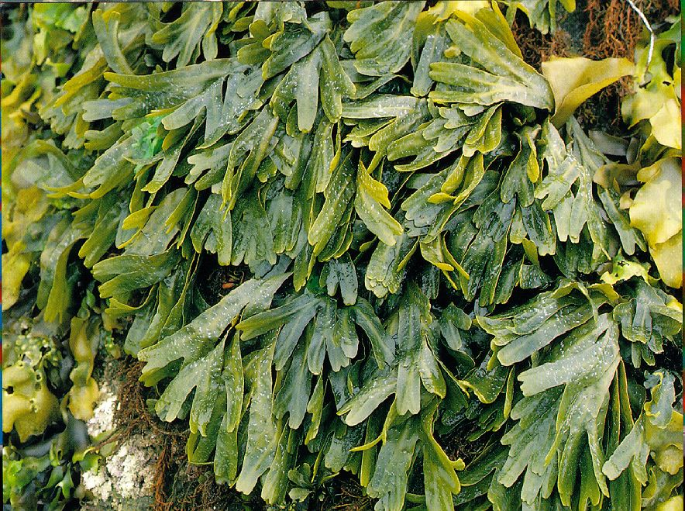
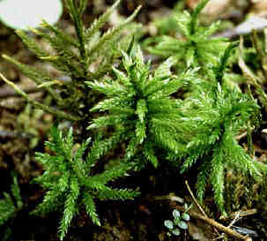
Appendix 5

Seaweed (Alga) Moss
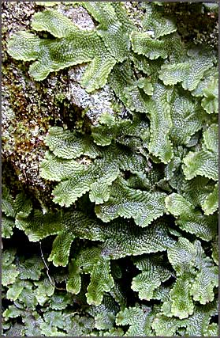
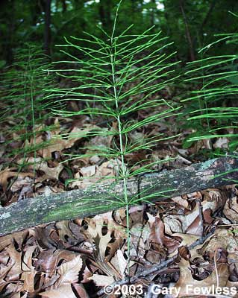

Liverwort Horsetail
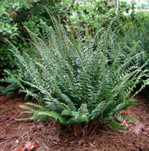
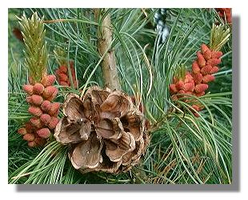
Fern Conifer
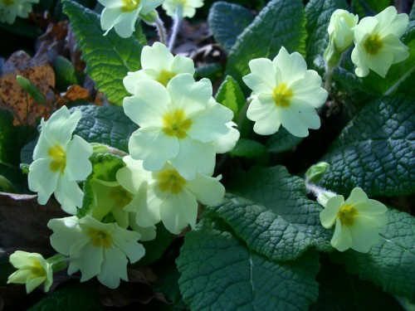
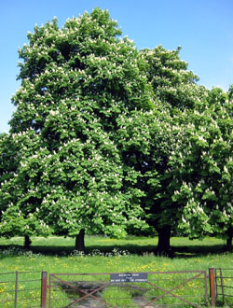

Flowering Plant (Primrose) Flowering Plant (Horse Chestnut)

Appendix 6 Feeding Relationships
Predator/Prey Adaptations
A predator is an animal that feeds by catching, killing and eating other animals. Adaptations shown by the peregrine falcon include:
- Sharp, hooked talons to grab and hold prey
- Sharp, hooked beak to rip prey apart
- Large eyes facing forwards to judge distance accurately
- Streamlined shape and large wings to swoop rapidly through the air

A prey animal is the food source of a predator. To survive, it needs to be able to avoid being caught. Adaptations shown by the rabbit include:
- Large ear flaps to sense the direction of sounds
- Large eyes on the sides of its head for good all round vision
- Drab brown fur for camouflage
- Strong back legs to run quickly

Food Chains
Food chains are used to represent feeding relationships in a habitat. The following points are important:
- Food chains begin with a plant because plants are able to use light energy from the sun to produce food (sugar and starch) by photosynthesis. To do this they also need the green pigment chlorophyll in their leaves and a supply of water and carbon dioxide.

- Because of their ability to produce their own food, plants are called producers.

- All animals obtain their food by eating – either plants or other animals. They are called consumers. The first animal in a food chain, that feeds on the plant, is called the first consumer. Because it is eating a plant, it is also a herbivore.

- The second animal in a food chain, that feeds on the first consumer, is called the second consumer. Because it is eating an animal, it is also a carnivore.

- The animal at the end of a food chain, which is not eaten by any other animal, is called the top carnivore.

- The arrows in a food chain represent the flow of energy, so they go from the food to the feeder. (Think of the arrow as meaning ‘is eaten by by’)

- Most food chains are relatively short (3, 4 or 5 organisms) because energy is ‘lost’, or transferred out of the food chain at each stage. For example, when a mole eats a worm, the mole uses some of the energy it receives from the worm to move about and maintain its body temperature. Some of the energy is also excreted in waste products. This means that only a small proportion of the energy consumed is used to make the mole grow bigger and only this energy is available pass onto the next animal in the chain.

Appendix 7 Some information to help build up food chains and webs
Organism | Feeds on | Eaten by
‘Non-woody’ plants  (Grass, lettuce, primrose, honeysuckle, foxglove, bugle, vetch, forget-me-not, clover)  Producers | Produce food by Photosynthesis | Butterfly, bee, hoverfly, moth (nectar)  Caterpillar, slug, snail, grub (leaves)  Rabbit, deer (all parts)  Worm (dead leaves)  Sparrow, mouse (seeds)
Trees  (Hazel, hawthorn, oak, sweet chestnut)  Producers | Produce food by Photosynthesis | As for Flowers +  Thrush, blackbird (berries)  Squirrel, mouse (nuts, acorns)
Butterfly, hoverfly, moth, bee  Consumers, Herbivores | Nectar from flowers | Swallow, pied flycatcher, bat, spider
Caterpillar, snail, slug, grub,  worm  Consumers, Herbivores | Leaves from any plant | Thrush, hedgehog, woodpecker, blackbird
Rabbit  Consumer, Herbivore | Leaves from any plant | Fox, stoat, kestrel, hobby, buzzard, owl
Squirrel  Consumer, Herbivore | Nuts (hazel, chestnut, oak) | Fox, stoat, kestrel, hobby, buzzard, owl
Sparrow, mouse  Consumer, Herbivore | Nuts and seeds from any plant | Fox, stoat, kestrel, hobby, buzzard, owl
Deer  Consumer, Herbivore | Leaves from any plant | Fox
Spider  Consumer, Carnivore | Flying insects | Swallow, pied flycatcher
Hedgehog  Consumer, Carnivore | Caterpillar, snail, slug, grub, worm | Fox – spiny coat protects from most predators
Swallow, pied flycatcher  Consumer, Carnivore | Flying insects, spider | Fox, stoat, kestrel, hobby, buzzard, owl
Thrush, blackbird  Consumers, Carnivores or Herbivores | Caterpillar, snail, slug, grub, worm  Berries (hawthorn) | Fox, stoat, kestrel, hobby, buzzard, owl
Woodpecker  Consumer, Carnivore | Grub | Kestrel, hobby, buzzard, owl
Bat  Consumer, Carnivore | Moth | Owl
Fox, stoat  Consumers, Top carnivores | Rabbit, squirrel, mouse, | No natural predators
Kestrel, hobby, buzzard, owl  Consumers, Top carnivores | Rabbit, squirrel, mouse,  swallow, blackbird, pied flycatcher, thrush, sparrow, woodpecker | No natural predators

